**Figure 1:** Bottom-up methane emission inventories used as prior estimates for the inversion. Panels show annual mean methane emissions for different sectors. Anthropogenic sectors are given by the gridded versions of the inventories of Canada (ECCC), the U.S. (EPA GHGI), and Mexico (INECC). Wetland emissions are given by the high-performance subset of the WetCHARTs version 1.3.1 wetlands inventory ensemble. Emissions are shown on the 0.25° × 0.3125° GEOS-Chem grid used for the inversion.

**Figure 2:** TROPOMI methane observations in 2019. The left panel shows the annual average column dry methane mixing ratios (XCH4) for 2019 averaged on the 0.25° × 0.3125° GEOS-Chem grid. The right panel shows the number of observations for the year on the same grid. The observations have been filtered as described in section 2.4.

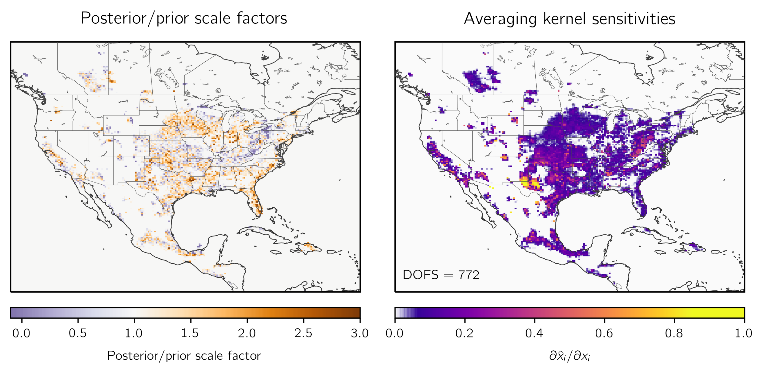

**Figure 3:** Optimization of methane emissions for 2019 by inversion of TROPOMI observations. The left panel shows the scale factors relative to the gridded versions of the national anthropogenic emissions inventories for the U.S. (EPA GHGI), Mexico (INECC), and Canada (ECCC) and the WetCHARTs wetland emissions used as prior estimates for the inversion (top left panel of Figure 1). The right panel shows the observing system information content as measured by the averaging kernel sensitivities (the diagonal elements of the averaging kernel matrix). Values of 1 indicate that TROPOMI quantifies emissions independently of the prior estimate, while values of 0 indicate that emissions are not optimized by the inversion. The sum of the averaging kernel sensitivities gives the degrees of freedom for signal (DOFS), shown inset, which defines the number of pieces of information independently quantified by the observing system. Grid cells with averaging kernel sensitivities less than 0.05 are left blank.

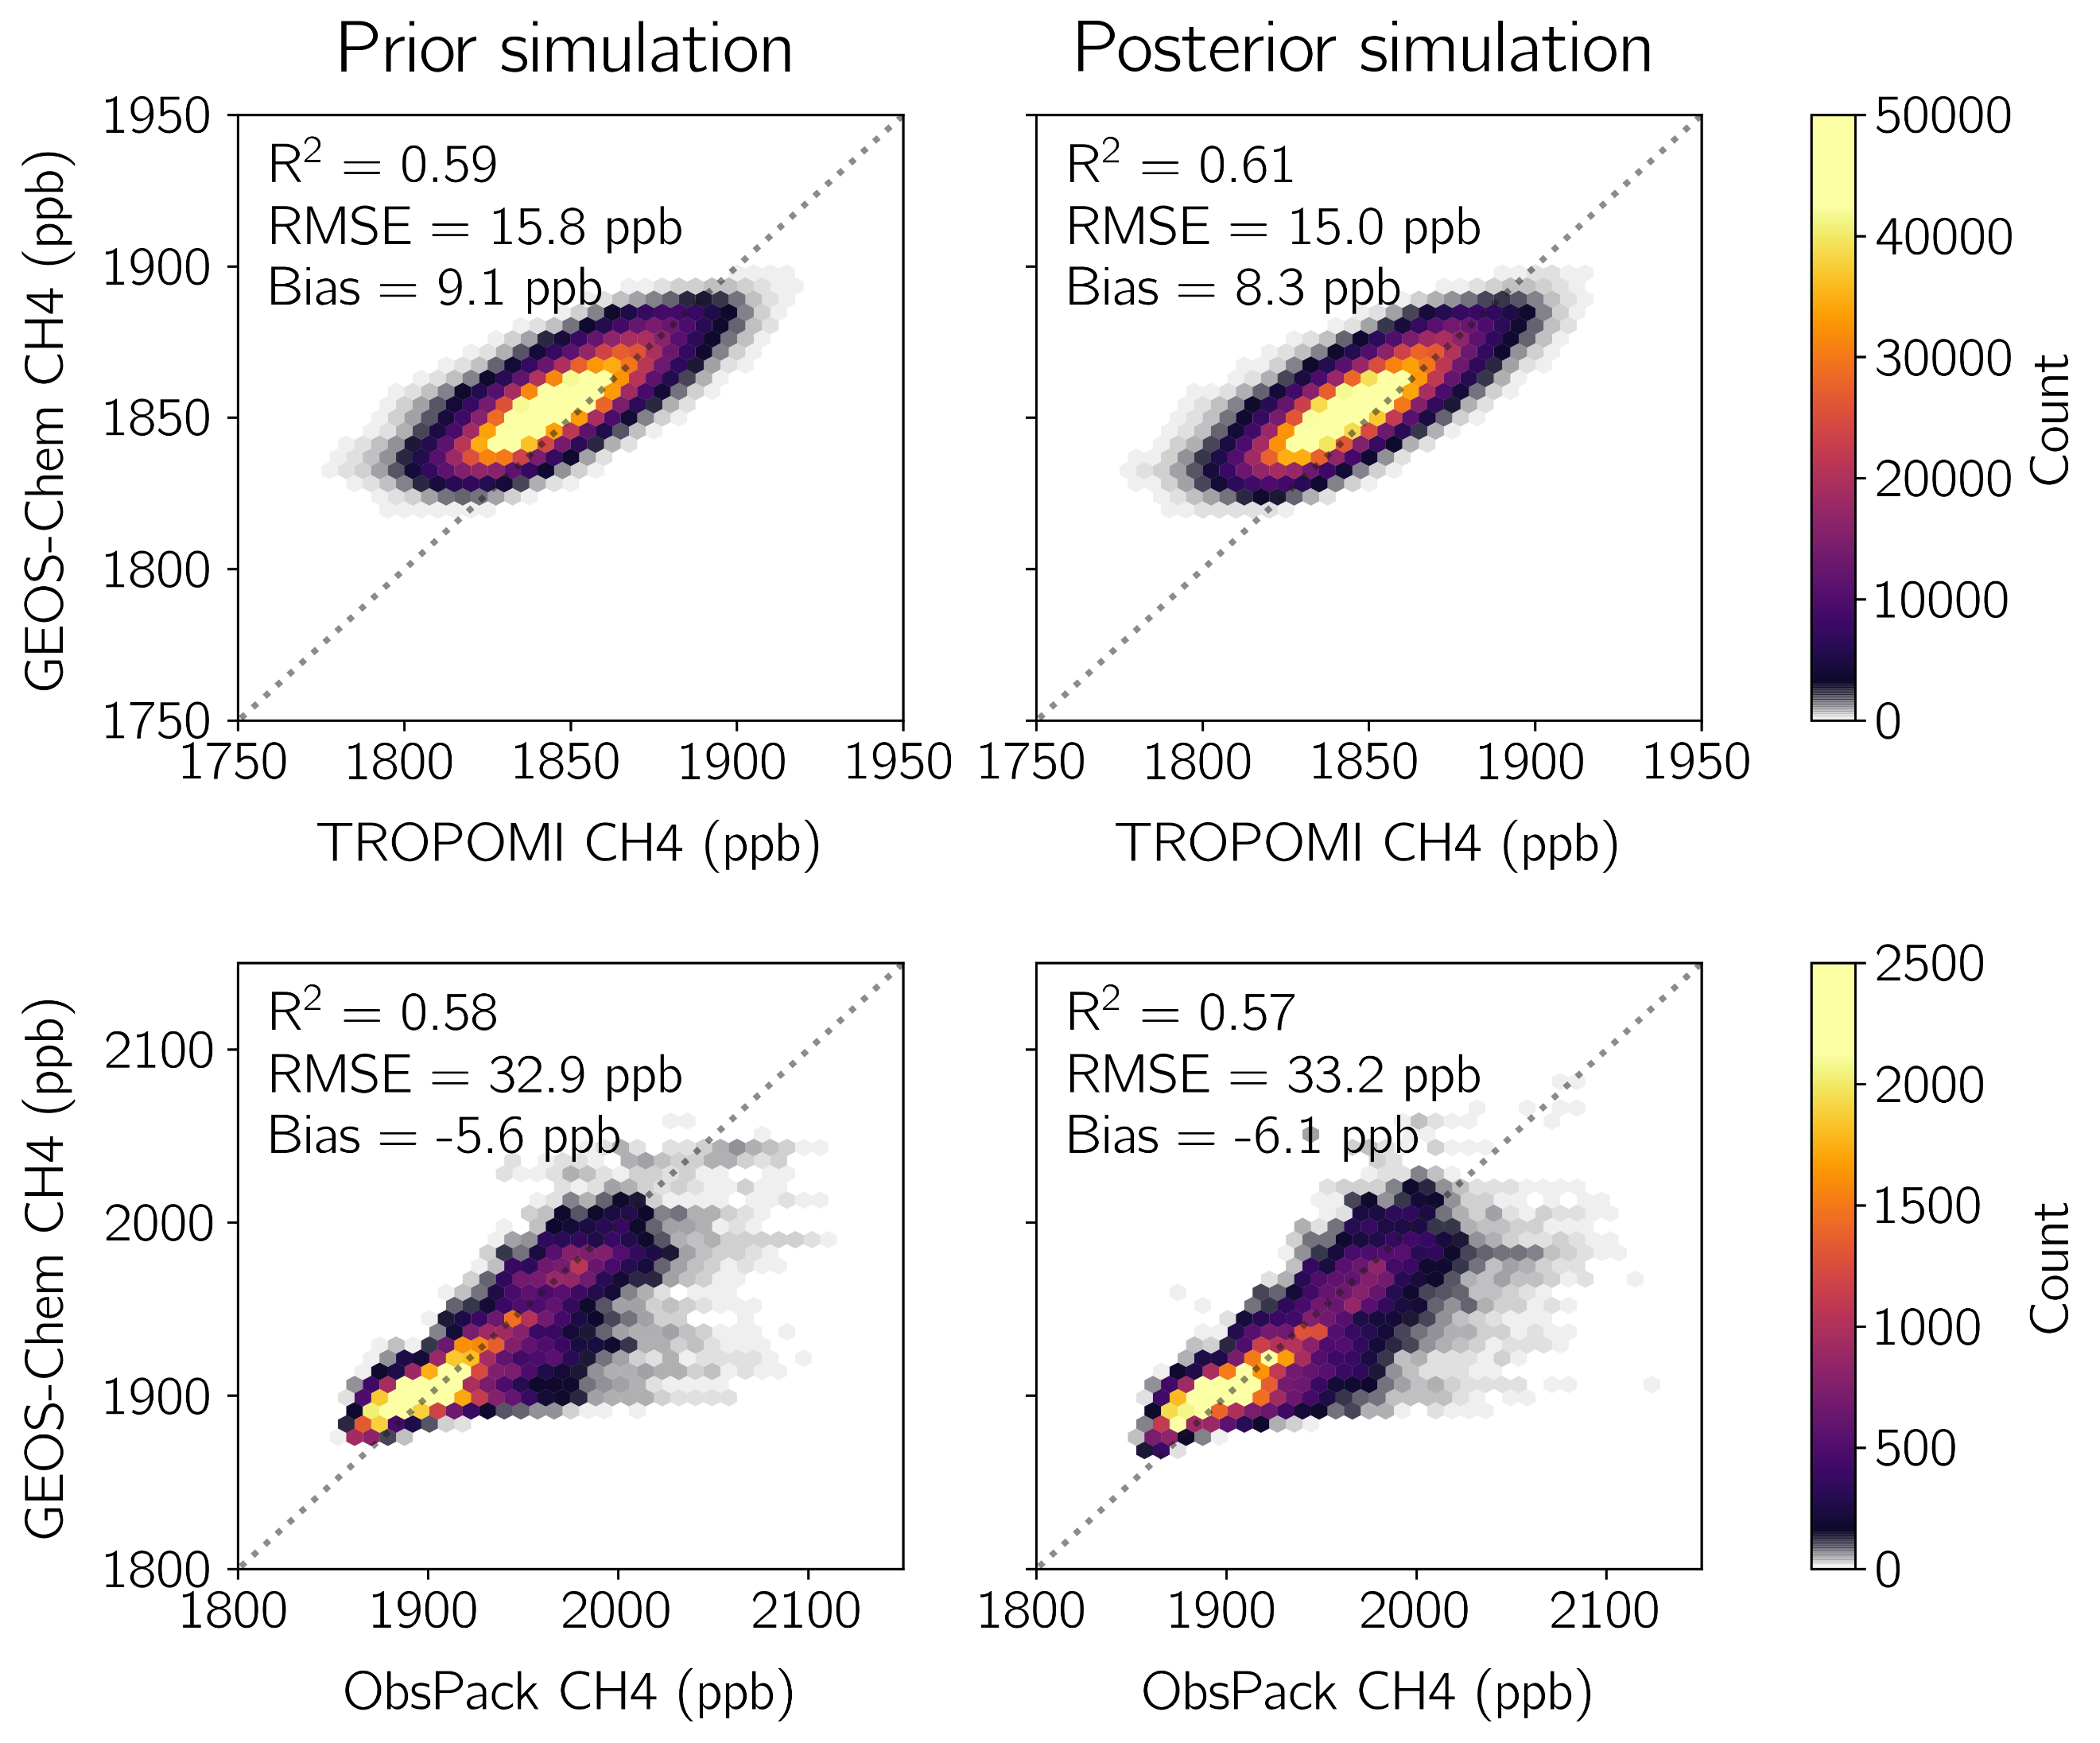

**Figure 4:** Evaluation of the prior and posterior emissions with methane observations from TROPOMI and from NOAA’s GLOBALVIEWplus CH4 ObsPack v3.0 database. All panels show simulated concentrations from GEOS-Chem (y-axis) plotted against the observations (x-axis). We plot data density instead of individual data points. The left column shows concentrations from a GEOS-Chem simulation driven by the prior emissions, and the right column shows concentrations from a simulation driven by posterior emissions. The top row shows the comparison with TROPOMI atmospheric methane columns, and the bottom row shows the comparison to ObsPack. Inset are the squared Pearson correlation coefficient (R2), root mean squared error (RMSE), and mean bias for each comparison.

**Figure 5:** Sectoral methane emissions in the contiguous United States (CONUS) for 2019. The 2022 EPA GHGI emissions for 2019 (top bars) and posterior estimates given by inversion of TROPOMI data for 2019 (bottom bars) are shown for different sectors. For wetland emissions we show the WetCHARTs estimate (top bar). The shading corresponds to emissions that occur in grid cells that are optimized by the inversion (grid cells with averaging kernel sensitivities greater than 0.05), while the white represents emissions not optimized by the inversion so that the posterior defaults to the prior estimate. Error bars on the posterior emissions are given by the spread of the eight-member inversion ensemble. Also shown are inversion results with error bars from Lu et al. (2022), and Shen et al. (2022) for oil and gas.

**Figure 6:** Methane emissions for 2019 from 73 individual landfills that report 2.5 Gg a-1 or more methane emissions to the EPA’s Greenhouse Gas Reporting Program (GHGRP) for 2019 and for which our TROPOMI inversion provides site-specific information as posterior estimates. The left panel shows the location of the landfills, with insets for parts of California (left) and Illinois and Indiana (right). Posterior emissions for each landfill are shown by the size of the marker. The colors show differences (Δ) between the posterior and GHGRP emissions for 2019, with red colors indicating posterior emissions larger than the reported value. Facilities that collect landfill gas are shown as circles, and others are shown as diamonds. The numbers (1 to 10) identify the top 10 methane-producing landfills listed in Table 3, and the letters (a to i) identify the nine validation sites listed in the right panel and outlined in gold. Validation sites are those with independent estimates available from aircraft campaigns given in references. The right panel shows GHGRP (top bars) and posterior (bottom bars) emissions for the validation sites, along with values reported from the aircraft campaigns. Sites are (a) Seneca Meadows in New York, (b) …

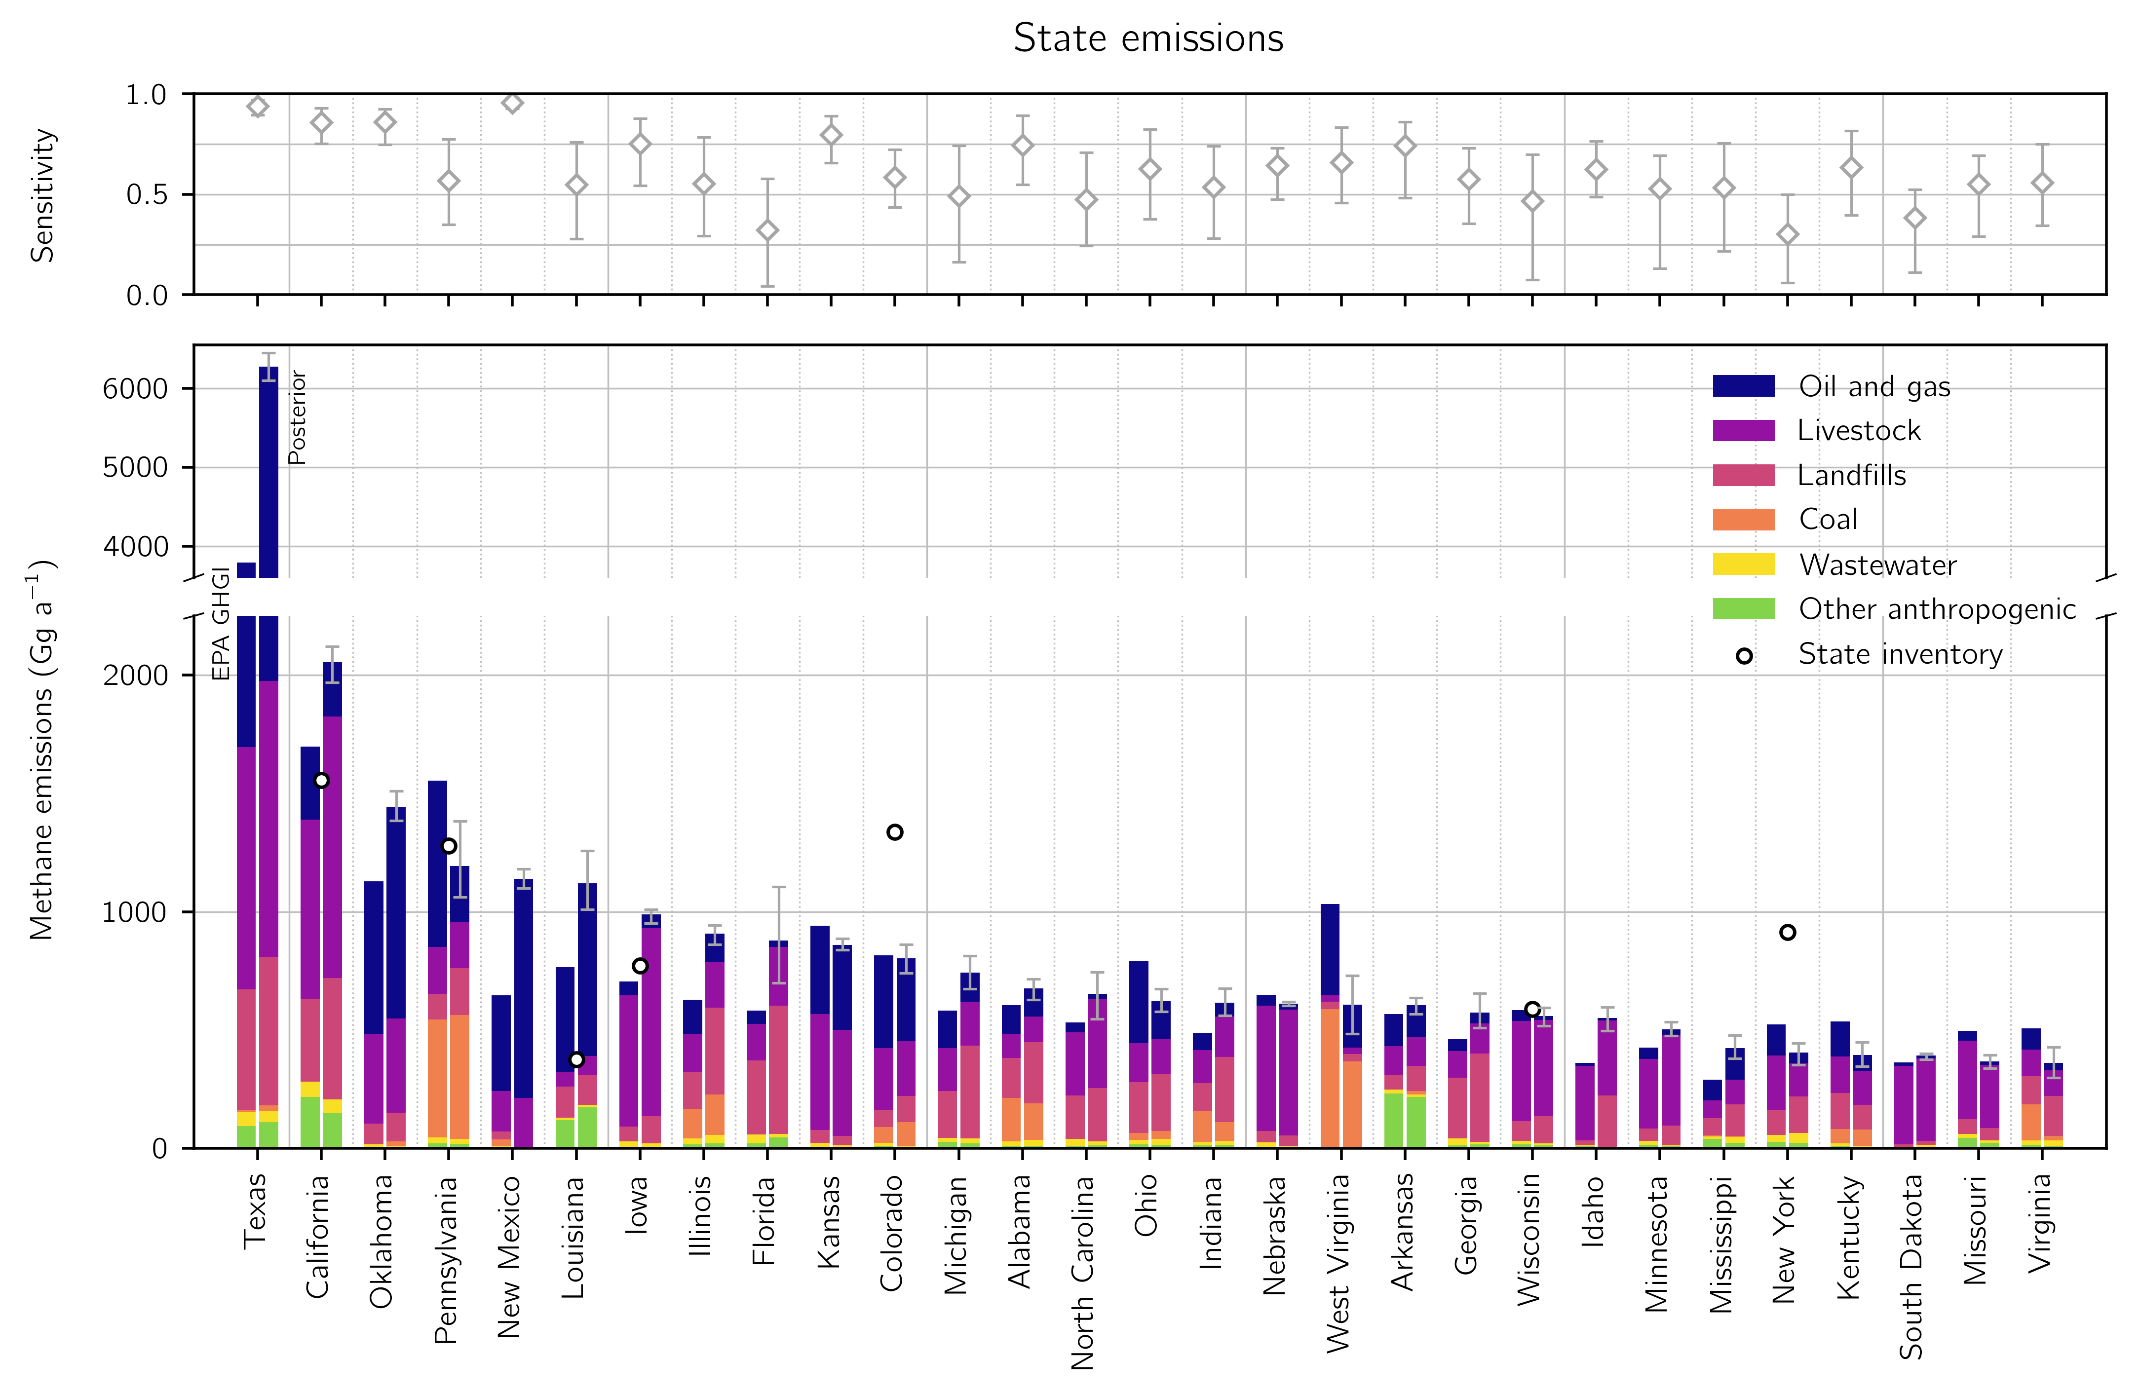

**Figure 7:** Anthropogenic methane emissions in 2019 for the 29 states responsible for 90% of national US anthropogenic posterior emissions. The bottom panel shows 2022 EPA GHGI state estimates for 2019 (left bar) and our posterior estimates from the inversion of TROPOMI data (right bar) divided by sector. States are listed from largest to smallest posterior emissions. The information content from the TROPOMI data as defined by the reduced-form averaging kernel sensitivities (the diagonal elements of the reduced-form averaging kernel matrix; section 2.8) is shown in the top panel: 1 = full sensitivity, 0 = no sensitivity. The error bars give the spread from the eight-member inversion ensemble. Also shown are emissions estimates from independent state inventories referenced by EPA (2022).

**Figure 8:** Anthropogenic methane emissions for the largest 10 methane-producing urban areas in the contiguous United States (CONUS) for 2019 as identified by inversion of TROPOMI data. Urban area extents are given by the U.S. Census Bureau TIGER/Line files (U.S. Census, 2010). The top bars show prior anthropogenic sectoral emissions from the 2022 EPA GHGI for 2019 allocated spatially following Maasakkers et al. (2016) with post-meter emissions allocated by population. The bottom bar shows posterior emissions from the TROPOMI inversion for 2019. We do not resolve posterior sectoral emissions estimates due to source colocation within urban areas on the scale of the inversion. Total emissions (left panel), per capita emissions (center panel), and averaging kernel sensitivities (right panel) are shown for each urban area. Error bars represent the spread of the eight-member inversion ensemble. Also shown are independent urban emissions estimates.

**Table 1:** The 8 members of the inversion ensemble.

|  |  |  |  |
| --- | --- | --- | --- |
| **Optimized boundary conditions**1 | **Latitude correction**2 | **Prior error standard deviation**3 | **Regularization factor**3 |
| Yes | Yes | 50% | 0.2 |
| 75% | 0.45 |
| Yes | No | 50% | 0.175 |
| 75% | 0.3 |
| 100% | 0.5 |
| No | Yes | 50% | 0.175 |
| 75% | 0.35 |
| No | No | 75% | 0.175 |

We conduct inversions that either do or do not optimize the boundary conditions. In inversions with optimized boundary conditions, we include in the inversion state vector four boundary condition elements corresponding to the northern, eastern, southern, and western borders of the North American domain.

2 We conduct inversions that either do or do not correct the latitudinal bias in the prior (model – observation) difference with a first order polynomial. In inversions without a latitudinal correction, we remove the mean prior (model – observation) difference as driven by boundary condition biases.

3 We balance the prior and observing system errors to avoid overfitting the emissions to the observations. The regularization factor $γ$ is applied to the inverse observing system error covariance matrix $S_{O}^{-1}$ so that values less than one increase the observing system errors. We choose the value of the regularization factor and the prior error standard deviation for a given inversion so that the prior term of the posterior cost function is approximately one as required by chi-squared statistics (section 2.7).

**Table 2:** 2019 methane emissions for the contiguous United States (CONUS).

|  |  |  |  |
| --- | --- | --- | --- |
|  | **Inventory emissions**1 | **Posterior emissions**2 | **Sensitivity**3 |
| **Total sources (Tg a-1)** | 34.5 | 39.3 (38.2 - 40.3) |  |
| **Anthropogenic sources** | 26.7 | 30.9 (30.0 - 31.8) |  |
| Livestock | 9.4 (8.6 - 10.2) | 10.4 (10.0 - 10.7) | 0.66 (0.55 - 0.76) |
| Oil and gas | 8.7 (7.4 - 10.2) | 10.4 (10.1 - 10.7) | 0.91 (0.88 - 0.95) |
| Coal | 2.1 (2.0 - 2.5) | 1.5 (1.2 - 1.9) | 0.60 (0.45 - 0.80) |
| Landfills | 4.5 (3.5 - 5.5) | 6.9 (6.4 - 7.5) | 0.47 (0.34 - 0.64) |
| Wastewater | 0.7 (0.5 - 0.9) | 0.6 (0.5 - 0.7) | 0.33 (0.16 - 0.60) |
| Other anthropogenic | 1.2 (0.7 - 1.8) | 1.1 (1.0 - 1.2) | 0.59 (0.44 - 0.76) |
| **Natural sources** | 7.8 | 8.4 (8.1 - 8.6) |  |
| Wetlands | 6.6 | 7.2 (7.0 - 7.4) | 0.35 (0.16 - 0.55) |
| Other biogenic | 1.1 | 1.2 (1.2 - 1.2) | 0.25 (0.19 - 0.32) |

1Inventory estimates of sectoral methane emissions. Anthropogenic emissions are given by the EPA 2022 GHGI for 2019, with error rangesinferred from the sum in quadrature of bottom-up subsector errors given as 95% confidence intervals. Wetland emissions are from a subset of the high performance WetCHARTs ensemble version 1.3.1. See section 2.2 for details.

2Optimized emissions from the inversion of TROPOMI data, with the range from the eight members of the inversion ensemble shown in parentheses.

3The sensitivity of the posterior emissions to the observing system as given by the diagonal elements of the sectoral averaging kernel matrix calculated as described in section 2.8. The values in parentheses give the range of the inversion ensemble. Values range from 0 (no sensitivity) to 1 (full sensitivity).

**Table 3:** Top 10 methane-producing landfills in CONUS for 2019.1

|  |  |  |  |  |  |  |
| --- | --- | --- | --- | --- | --- | --- |
| **Facility** | **Location** | **Emission (Gg a-1)** | | | **Gas capture efficiency** | |
| **GHGRP**2 | | **Posterior**3 | **GHGRP**4 | **Posterior**5 |
| 1. National Serv-All Landfill6 | Fort Wayne, IN | 3.4 | 44 (34 - 59) | | 0.86 | 0.32 (0.26 - 0.37) |
| 2. South Shelby Landfill7 | Memphis, TN | 4.1 | 41 (30 - 56) | | 0.86 | 0.39 (0.31 - 0.46) |
| 3. South Side Landfill Inc.8 | Indianapolis, IN | 4.7 | 39 (32 - 52) | | N/A | N/A |
| 4. Rumpke Sanitary Landfill | Cincinnati, OH | 10.1 | 39 (33 - 43) | | 0.84 | 0.58 (0.55 - 0.61) |
| 5. Quad Cities Landfill Phase IV | Milan, IL | 3.7 | 35 (28 - 47) | | N/A | N/A |
| 6. City of Dothan Sanitary Landfill9 | Dothan, AL | 5.8 | 35 (28 - 43) | | N/A | N/A |
| 7. Rochelle Municipal Landfill | Rochelle, IL | 2.7 | 32 (25 - 39) | | 0.76 | 0.22 (0.18 - 0.26) |
| 8. Seminole Road MSW Landfill | Ellenwood, GA | 12.3 | 30 (25 - 36) | | 0.18 | 0.08 (0.07 - 0.10) |
| 9. Caterpillar Inc.-Mapleton | Mapleton, IL | 6.4 | 25 (23 - 29) | | N/A | N/A |
| 10. Sampson County Disposal, LLC | Roseboro, NC | 29.2 | 24 (22 - 25) | | 0.37 | 0.41 (0.38 - 0.44) |

1The top 10 landfills with the largest posterior methane emissions from the TROPOMI inversion for 2019. Numbers correspond to the labels in Figure 6

2Emissions reported by individual landfills to the EPA GHGRP for 2019 in gigagrams per year.

3Posterior emissions from inversion of TROPOMI observations in gigagrams per year. See text for the allocation of posterior emissions to individual facilities. Values in parentheses represent the range from the eight-member inversion ensemble.

4For facilities that capture landfill gas, the recovery efficiency as calculated from emissions and avoided emissions reported by individual landfills to the EPA LMOP. Facilities that do not capture landfill gas are listed as N/A.

5The posterior recovery efficiency as calculated from posterior emissions and the avoided emissions reported by individual landfills to the EPA LMOP.

6A nearby landfill closed permanently in March 2019, increasing the waste received by this facility.

7Construction was likely underway in 2019 on a landfill gas pipeline injection facility at this landfill, which can now produce the equivalent of almost 33250 gallons of gasoline per day.

8Construction began on a landfill gas facility that would generate 8 million gallons of gas per year in June 2019.

9The landfill has been full since 2014, after which the facility reports declining emissions.

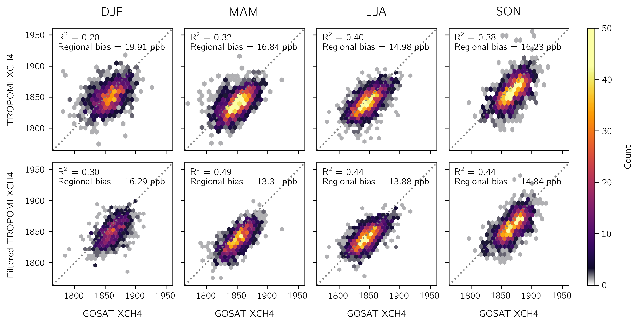**Figure S1:** Evaluation of the TROPOMI methane data with GOSAT observations. Each panel shows the TROPOMI data (y-axis) plotted against the GOSAT observations (x-axis), each averaged on a 2° × 2° grid over the North America domain (Figure 2). Data density is shown instead of individual points. Columns show data for each season. The top row shows the unfiltered TROPOMI data with only the standard quality assessment filter applied. The bottom row shows the filtered TROPOMI data that removes observations over scenes that are likely snow- and ice-covered following section 2.4. Inset are the squared Pearson correlation coefficient (R2) and the regional bias defined as the standard deviation of the grid-cell-to-grid-cell bias.

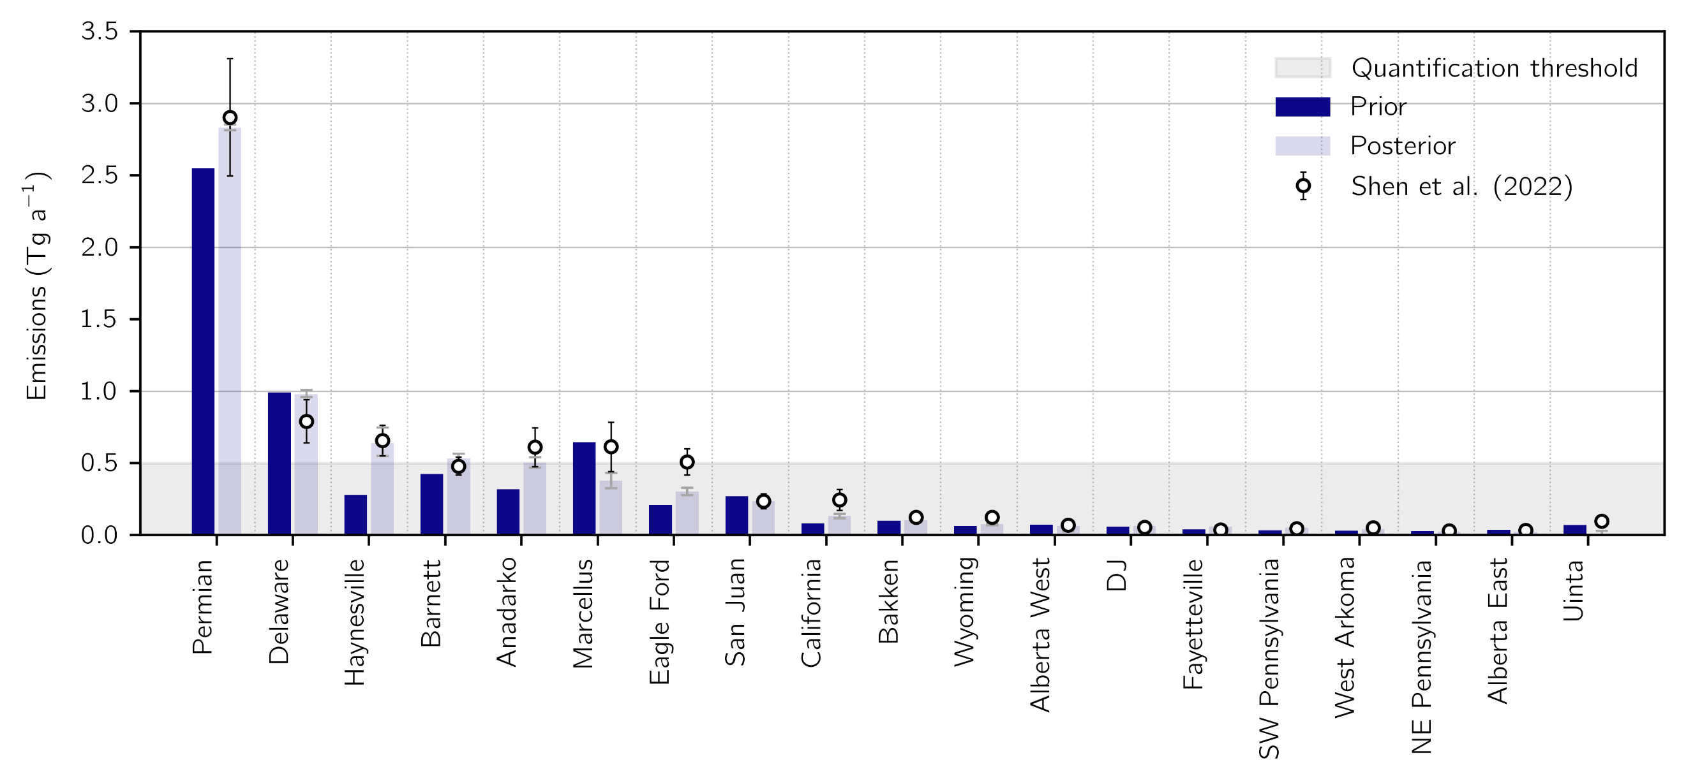

**Figure S2:** Methane emissions from the oil and gas sector for individual basins across North America for 2019. Basin boundaries are defined following Shen et al. (2022). Prior emissions (left bars) are given by the 2020 EPA GHGI for 2018 allocated using the Gridded EPA inventory (Maasakkers et al., 2016) with the distribution of production fields updated for 2018 following Shen et al. (2022). The posterior emissions given by inversion of TROPOMI data for 2019 are shown in the right bars. Error bars are given by the eight-member ensemble range. Also shown are basin estimates, error bars, and the 0.5 Tg a-1 threshold for successful emission quantification from Shen et al. (2022).

**Table S1:** Methane emissions from the 48 states in the contiguous United States for 2019.

|  |  |  |  |  |  |  |  |  |  |  |  |  |  |  |  |
| --- | --- | --- | --- | --- | --- | --- | --- | --- | --- | --- | --- | --- | --- | --- | --- |
| **Emissions (Gg a-1)**1 | **Livestock** | | **Oil and gas** | | **Coal** | | **Landfills** | | **Wastewater** | | **Other anthropogenic** | | **Total** | | |
| **State** | **GHGI**2 | **x̂**3 | **GHGI** | **x̂** | **GHGI** | **x̂** | **GHGI** | **x̂** | **GHGI** | **x̂** | **GHGI** | **x̂** | **GHGI** | **x̂**4 | **DOFS**5 |
| 1. Texas | 1023 | 1165 | 2096 | 4299 | 9 | 24 | 509 | 627 | 60 | 48 | 94 | 110 | 3790 | 6274 (6101, 6454) | 0.94 (0.89, 0.97) |
| 2. California | 760 | 1104 | 309 | 231 | 0 | 0 | 348 | 514 | 65 | 58 | 217 | 148 | 1698 | 2055 (1970, 2122) | 0.86 (0.75, 0.93) |
| 3. Oklahoma | 380 | 399 | 643 | 894 | 3 | 20 | 86 | 121 | 10 | 3 | 7 | 6 | 1128 | 1444 (1384, 1511) | 0.86 (0.75, 0.92) |
| 4. Pennsylvania | 199 | 196 | 703 | 238 | 498 | 524 | 109 | 196 | 25 | 20 | 22 | 20 | 1555 | 1194 (1061, 1384) | 0.57 (0.35, 0.77) |
| 5. New Mexico | 170 | 211 | 406 | 925 | 28 | 32 | 34 | -34 | 3 | 2 | 6 | 3 | 647 | 1139 (1100, 1180) | 0.96 (0.93, 0.98) |
| 6. Louisiana | 62 | 79 | 443 | 731 | 1 | 2 | 131 | 126 | 10 | 9 | 119 | 174 | 766 | 1121 (1010, 1258) | 0.55 (0.28, 0.76) |
| 7. Iowa | 555 | 793 | 57 | 59 | 0 | 0 | 63 | 116 | 23 | 13 | 6 | 7 | 705 | 989 (952, 1010) | 0.75 (0.54, 0.88) |
| 8. Illinois | 160 | 191 | 143 | 121 | 126 | 170 | 157 | 368 | 25 | 37 | 17 | 21 | 627 | 907 (862, 944) | 0.55 (0.29, 0.79) |
| 9. Florida | 155 | 250 | 56 | 26 | 0 | 0 | 311 | 540 | 38 | 15 | 22 | 47 | 582 | 878 (699, 1106) | 0.32 (0.04, 0.58) |
| 10. Kansas | 490 | 448 | 373 | 358 | 0 | 0 | 54 | 41 | 18 | 9 | 5 | 3 | 940 | 860 (839, 888) | 0.80 (0.66, 0.89) |
| 11. Colorado | 263 | 232 | 392 | 351 | 65 | 102 | 72 | 110 | 14 | 4 | 10 | 5 | 816 | 804 (740, 861) | 0.59 (0.44, 0.72) |
| 12. Michigan | 182 | 187 | 160 | 121 | 0 | 0 | 196 | 392 | 18 | 19 | 27 | 22 | 582 | 742 (674, 813) | 0.49 (0.16, 0.74) |
| 13. Alabama | 102 | 109 | 122 | 120 | 183 | 154 | 168 | 259 | 21 | 25 | 10 | 11 | 605 | 677 (629, 717) | 0.75 (0.55, 0.89) |
| 14. North Carolina | 266 | 375 | 41 | 23 | 0 | 0 | 185 | 225 | 28 | 17 | 12 | 13 | 531 | 654 (547, 744) | 0.48 (0.24, 0.71) |
| 15. Ohio | 165 | 146 | 348 | 160 | 30 | 32 | 214 | 244 | 19 | 24 | 18 | 16 | 793 | 622 (578, 673) | 0.63 (0.38, 0.82) |
| 16. Indiana | 140 | 170 | 74 | 60 | 132 | 79 | 115 | 274 | 15 | 17 | 13 | 16 | 489 | 616 (561, 676) | 0.54 (0.28, 0.74) |
| 17. Nebraska | 531 | 533 | 45 | 24 | 0 | 0 | 47 | 46 | 22 | 5 | 4 | 3 | 649 | 611 (604, 619) | 0.64 (0.48, 0.73) |
| 18. West Virginia | 28 | 26 | 386 | 182 | 582 | 360 | 30 | 32 | 3 | 2 | 5 | 4 | 1033 | 607 (485, 730) | 0.66 (0.46, 0.83) |
| 19. Arkansas | 124 | 122 | 136 | 134 | 0 | 13 | 61 | 106 | 15 | 10 | 233 | 218 | 568 | 605 (569, 636) | 0.74 (0.48, 0.86) |
| 20. Georgia | 114 | 127 | 51 | 47 | 0 | 0 | 256 | 374 | 28 | 9 | 14 | 18 | 462 | 575 (509, 655) | 0.58 (0.35, 0.73) |
| 21. Wisconsin | 424 | 407 | 46 | 16 | 0 | 0 | 83 | 114 | 15 | 8 | 17 | 14 | 584 | 559 (518, 595) | 0.47 (0.07, 0.70) |
| 22. Idaho | 316 | 317 | 13 | 11 | 0 | 0 | 20 | 219 | 5 | 2 | 8 | 3 | 362 | 551 (498, 596) | 0.63 (0.49, 0.76) |
| 23. Minnesota | 295 | 381 | 48 | 26 | 0 | 0 | 52 | 83 | 16 | 4 | 15 | 10 | 426 | 504 (475, 534) | 0.53 (0.13, 0.69) |
| 24. Mississippi | 77 | 104 | 87 | 132 | 3 | 6 | 73 | 134 | 11 | 24 | 40 | 23 | 291 | 423 (380, 478) | 0.53 (0.22, 0.75) |
| 25. New York | 230 | 139 | 131 | 47 | 0 | 0 | 107 | 154 | 29 | 43 | 27 | 23 | 524 | 405 (352, 445) | 0.30 (0.06, 0.50) |

|  |  |  |  |  |  |  |  |  |  |  |  |  |  |  |  |
| --- | --- | --- | --- | --- | --- | --- | --- | --- | --- | --- | --- | --- | --- | --- | --- |
| **Emissions (Gg a-1)**1 | **Livestock** | | **Oil & gas** | | **Coal** | | **Landfills** | | **Wastewater** | | **Other anthropogenic** | | **Total** | | |
| **State** | **GHGI**2 | **x̂**3 | **GHGI** | **x̂** | **GHGI** | **x̂** | **GHGI** | **x̂** | **GHGI** | **x̂** | **GHGI** | **x̂** | **GHGI** | **x̂**4 | **DOFS**5 |
| 26. Kentucky | 154 | 143 | 148 | 68 | 61 | 69 | 152 | 105 | 11 | 4 | 9 | 7 | 536 | 395 (347, 449) | 0.64 (0.40, 0.82) |
| 27. South Dakota | 332 | 347 | 13 | 12 | 0 | 0 | 11 | 18 | 5 | 12 | 2 | 2 | 362 | 392 (376, 401) | 0.38 (0.11, 0.53) |
| 28. Missouri | 331 | 266 | 42 | 14 | 0 | 0 | 64 | 54 | 16 | 9 | 44 | 24 | 497 | 367 (339, 394) | 0.55 (0.29, 0.69) |
| 29. Virginia | 112 | 109 | 88 | 31 | 153 | 20 | 119 | 169 | 20 | 22 | 14 | 11 | 507 | 362 (299, 428) | 0.56 (0.35, 0.75) |
| 30. Tennessee | 132 | 122 | 54 | 40 | 2 | 2 | 114 | 132 | 13 | 20 | 9 | 7 | 324 | 322 (301, 349) | 0.60 (0.33, 0.77) |
| 31. Montana | 215 | 211 | 87 | 63 | 20 | 10 | 13 | 19 | 2 | 1 | 8 | 3 | 344 | 306 (292, 322) | 0.31 (0.22, 0.40) |
| 32. North Dakota | 136 | 124 | 139 | 141 | 5 | 6 | 18 | 26 | 2 | 2 | 3 | 2 | 302 | 300 (286, 317) | 0.59 (0.41, 0.70) |
| 33. Washington | 147 | 149 | 25 | 20 | 0 | 0 | 70 | 98 | 16 | 14 | 21 | 13 | 280 | 293 (269, 337) | 0.10 (0.04, 0.14) |
| 34. Utah | 92 | 105 | 103 | 49 | 28 | 79 | 30 | 49 | 6 | 0 | 5 | 3 | 265 | 285 (248, 336) | 0.74 (0.57, 0.87) |
| 35. Oregon | 115 | 132 | 24 | 23 | 0 | 0 | 55 | 111 | 7 | 3 | 14 | 8 | 215 | 276 (256, 304) | 0.08 (0.05, 0.11) |
| 36. Arizona | 121 | 141 | 50 | 41 | 1 | 2 | 70 | 72 | 11 | 4 | 6 | 3 | 259 | 263 (261, 266) | 0.80 (0.74, 0.84) |
| 37. South Carolina | 37 | 53 | 26 | 11 | 0 | 0 | 68 | 145 | 12 | 21 | 8 | 8 | 151 | 237 (220, 249) | 0.51 (0.20, 0.70) |
| 38. New Jersey | 4 | 4 | 44 | 51 | 0 | 0 | 56 | 116 | 13 | 35 | 11 | 27 | 128 | 233 (186, 294) | 0.28 (0.06, 0.52) |
| 39. Maryland | 23 | 28 | 19 | 20 | 2 | 4 | 44 | 57 | 12 | 4 | 8 | 7 | 109 | 120 (112, 126) | 0.26 (0.04, 0.45) |
| 40. Nevada | 45 | 49 | 20 | 9 | 0 | 0 | 17 | 30 | 4 | 2 | 3 | 2 | 90 | 93 (93, 93) | 0.00 (0.00, 0.00) |
| 41. Massachusetts | 4 | 4 | 29 | 17 | 0 | 0 | 24 | 48 | 10 | 4 | 9 | 7 | 76 | 80 (66, 93) | 0.15 (0.00, 0.35) |
| 42. Wyoming | 109 | 113 | 281 | 142 | 200 | -186 | 6 | 10 | 1 | 0 | 3 | 1 | 601 | 80 (-194, 279) | 0.68 (0.48, 0.86) |
| 43. Vermont | 38 | 29 | 1 | 0 | 0 | 0 | 6 | 13 | 1 | 1 | 6 | 3 | 52 | 46 (45, 49) | 0.02 (0.00, 0.07) |
| 44. Connecticut | 8 | 5 | 12 | 8 | 0 | 0 | 8 | 15 | 5 | 12 | 5 | 4 | 38 | 45 (35, 51) | 0.26 (0.01, 0.50) |
| 45. Maine | 11 | 10 | 4 | 2 | 0 | 0 | 13 | 20 | 3 | 1 | 10 | 6 | 40 | 38 (37, 39) | 0.00 (0.00, 0.00) |
| 46. New Hampshire | 4 | 5 | 3 | 1 | 0 | 0 | 21 | 16 | 3 | 1 | 6 | 3 | 36 | 25 (23, 27) | 0.03 (0.00, 0.08) |
| 47. Delaware | 3 | 4 | 5 | 2 | 0 | 0 | 17 | 8 | 5 | 5 | 1 | 2 | 31 | 20 (19, 22) | 0.12 (0.04, 0.23) |
| 48. Rhode Island | 0 | 1 | 5 | 4 | 0 | 0 | 6 | 11 | 2 | 2 | 2 | 1 | 15 | 18 (14, 21) | 0.19 (0.07, 0.34) |

Sectoral emissions in gigagrams per year (Gg a-1) for anthropogenic sources.

2Bottom-up emissions for each state from the 2022 EPA GHGI state estimates for 2019.

3Optimized sectoral anthropogenic emissions from an inversion of TROPOMI data for 2019.

4The total anthropogenic optimized emissions. Values in parentheses give the minimum and maximum of the ensemble of 8 inversions.

5The sensitivity of the total state posterior emissions to the observing system, given by the diagonal elements of the state averaging kernel matrix calculated. Values in parentheses give the ensemble range. Sensitivities range from 0 (unresponsive to the observing system) to 1 (fully responsive).

**Table S2:** Methane emissions from urban areas in the contiguous U.S. (CONUS) for 2019.

|  |  |  |  |  |  |  |  |
| --- | --- | --- | --- | --- | --- | --- | --- |
| **Urban area**1 | **Prior anthropogenic emissions (Gg a-1)**2 | | | | | **Posterior emissions** | |
| **Landfills** | **Wastewater** | **Post-meter gas** | **Landfills** | **Wastewater** | **Total (Gg a-1)** | **Landfills** |
| 1. New York-Newark, NY-NJ-CT | 67.5 | 40.4 | 27.3 | 36.7 | 35.9 | 309 (241, 417) | 0.28 (0.04, 0.54) |
| 2. Detroit, MI | 55.9 | 6.1 | 5.6 | 8.5 | 15.4 | 210 (170, 259) | 0.33 (0.14, 0.55) |
| 3. Atlanta, GA | 53.1 | 3.0 | 6.7 | 4.4 | 26.1 | 179 (157, 208) | 0.50 (0.33, 0.65) |
| 4. Dallas-Fort Worth-Arlington, TX | 68.4 | 11.8 | 7.6 | 17.3 | 136.3 | 362 (337, 384) | 0.52 (0.34, 0.70) |
| 5. Houston, TX | 44.4 | 5.4 | 7.4 | 15.2 | 67.4 | 209 (183, 236) | 0.36 (0.21, 0.51) |
| 6. Chicago, IL-IN | 73.4 | 21.7 | 12.8 | 15.2 | 31.8 | 207 (190, 224) | 0.38 (0.18, 0.58) |
| 7. Los Angeles-Long Beach-Anaheim, CA | 111.1 | 12.2 | 18.1 | 14.5 | 28.9 | 121 (116, 127) | 0.76 (0.62, 0.88) |
| 8. Cincinnati, OH-KY-IN | 41.3 | 12.2 | 2.4 | 3.3 | 8.4 | 98 (85, 109) | 0.48 (0.22, 0.74) |
| 9. Miami, FL | 72.4 | 8.6 | 8.2 | 2.7 | 12.4 | 284 (206, 395) | 0.24 (0.06, 0.44) |
| 10. Philadelphia, PA-NJ-DE-MD | 31.4 | 10.4 | 8.1 | 14.5 | 29.3 | 122 (108, 132) | 0.24 (0.07, 0.43) |
| 11. Indianapolis, IN | 22.1 | 1.4 | 2.2 | 3.6 | 15.6 | 101 (84, 127) | 0.34 (0.13, 0.60) |
| 12. Denver-Aurora, CO | 41.8 | 2.0 | 3.5 | 5.5 | 27.9 | 96 (76, 119) | 0.59 (0.43, 0.73) |
| 13. Reading, PA | 11.3 | 0.3 | 0.4 | 1.0 | 15.8 | 104 (66, 158) | 0.38 (0.15, 0.64) |
| 14. Memphis, TN-MS-AR | 19.9 | 7.7 | 1.6 | 1.4 | 15.5 | 81 (70, 96) | 0.49 (0.26, 0.71) |
| 15. Birmingham, AL | 31.1 | 5.5 | 1.1 | 2.0 | 81.6 | 248 (201, 310) | 0.50 (0.28, 0.74) |
| 16. Austin, TX | 22.8 | 1.0 | 2.0 | 4.1 | 9.9 | 67 (58, 82) | 0.53 (0.32, 0.75) |
| 17. Fort Wayne, IN | 7.8 | 0.5 | 0.5 | 0.8 | 5.2 | 58 (45, 74) | 0.31 (0.16, 0.50) |
| 18. San Diego, CA | 21.1 | 2.7 | 4.4 | 2.8 | 5.8 | 46 (43, 48) | 0.73 (0.56, 0.88) |
| 19. Davenport, IA-IL | 11.7 | 0.5 | 0.4 | 0.7 | 8.5 | 57 (48, 72) | 0.23 (0.11, 0.37) |
| 20. Rockford, IL | 20.9 | 0.5 | 0.4 | 0.8 | 5.6 | 49 (34, 54) | 0.33 (0.13, 0.58) |
| 21. Corpus Christi, TX | 16.6 | 0.8 | 0.5 | 1.2 | 21.0 | 79 (60, 117) | 0.21 (0.10, 0.34) |
| 22. Peoria, IL | 14.8 | 0.5 | 0.4 | 0.5 | 4.4 | 49 (43, 55) | 0.22 (0.10, 0.33) |
| 23. San Francisco-Oakland, CA | 24.2 | 13.2 | 4.9 | 3.3 | 14.2 | 69 (59, 87) | 0.30 (0.16, 0.44) |
| 24. San Antonio, TX | 21.9 | 5.9 | 2.6 | 5.2 | 19.4 | 51 (38, 63) | 0.33 (0.22, 0.44) |
| 25. Sacramento, CA | 25.3 | 1.9 | 2.6 | 2.2 | 30.1 | 67 (64, 71) | 0.53 (0.33, 0.71) |
| 26. Charlotte, NC-SC | 14.5 | 1.0 | 1.9 | 0.8 | 13.5 | 50 (42, 59) | 0.39 (0.21, 0.56) |
| 27. Minneapolis-St. Paul, MN-WI | 15.7 | 2.1 | 4.0 | 4.3 | 17.2 | 53 (42, 70) | 0.23 (0.07, 0.34) |
| 28. Phoenix-Mesa, AZ | 28.6 | 2.3 | 5.4 | 2.0 | 23.8 | 43 (40, 47) | 0.79 (0.67, 0.88) |
| 29. El Paso, TX-NM | 7.0 | 2.0 | 1.2 | 1.4 | 5.2 | 15 (13, 18) | 0.45 (0.33, 0.53) |
| **Urban area**1 | **Prior anthropogenic emissions (Gg a-1)**2 | | | | | **Posterior emissions** | |
| **Landfills** | **Wastewater** | **Post-meter gas** | **Landfills** | **Wastewater** | **Total (Gg a-1)** | **Landfills** |
| 30. Oklahoma City, OK | 17.2 | 0.7 | 1.3 | 3.7 | 17.9 | 59 (49, 71) | 0.53 (0.30, 0.75) |
| 31. Riverside-San Bernardino, CA | 14.4 | 2.4 | 2.9 | 2.0 | 13.1 | 40 (39, 42) | 0.43 (0.32, 0.54) |
| 32. Montgomery, AL | 8.5 | 4.1 | 0.4 | 0.7 | 5.6 | 32 (27, 37) | 0.20 (0.10, 0.31) |
| 33. Stockton, CA | 7.2 | 2.7 | 0.6 | 0.6 | 17.4 | 57 (47, 68) | 0.25 (0.14, 0.39) |
| 34. San Jose, CA | 12.0 | 4.2 | 2.5 | 1.7 | 2.6 | 26 (24, 32) | 0.31 (0.17, 0.47) |
| 35. Tulsa, OK | 14.2 | 0.6 | 1.0 | 3.0 | 12.9 | 36 (28, 43) | 0.39 (0.24, 0.54) |
| 36. Youngstown, OH-PA | 16.0 | 0.7 | 0.6 | 1.4 | 23.9 | 55 (48, 63) | 0.42 (0.21, 0.63) |
| 37. Grand Rapids, MI | 13.8 | 0.6 | 0.8 | 2.0 | 18.4 | 45 (41, 52) | 0.22 (0.05, 0.33) |
| 38. Tuscaloosa, AL | 11.6 | 0.2 | 0.2 | 0.4 | 21.0 | 55 (45, 69) | 0.50 (0.27, 0.74) |
| 39. Lancaster, PA | 4.2 | 0.6 | 0.6 | 1.4 | 22.5 | 64 (51, 78) | 0.31 (0.15, 0.47) |
| 40. Pittsburgh, PA | 13.4 | 2.9 | 2.6 | 6.1 | 277.5 | 415 (354, 502) | 0.47 (0.23, 0.71) |
| 41. Lexington-Fayette, KY | 9.2 | 0.3 | 0.4 | 0.4 | 6.8 | 27 (22, 33) | 0.37 (0.21, 0.54) |
| 42. Sioux Falls, SD | 2.1 | 5.3 | 0.2 | 0.2 | 6.8 | 32 (28, 39) | 0.33 (0.22, 0.48) |
| 43. Fairfield, CA | 9.9 | 0.6 | 0.2 | 0.3 | 3.8 | 23 (21, 24) | 0.24 (0.11, 0.38) |
| 44. St. Louis, MO-IL | 18.1 | 5.3 | 3.2 | 3.0 | 13.5 | 28 (21, 37) | 0.51 (0.24, 0.73) |
| 45. McKinney, TX | 5.5 | 0.2 | 0.3 | 0.6 | 2.1 | 21 (16, 32) | 0.42 (0.21, 0.65) |
| 46. Chattanooga, TN-GA | 13.7 | 0.7 | 0.6 | 0.6 | 6.0 | 22 (13, 31) | 0.33 (0.21, 0.45) |
| 47. Washington, DC-VA-MD | 12.3 | 6.3 | 6.8 | 7.0 | 16.0 | 29 (15, 39) | 0.24 (0.06, 0.39) |
| 48. Lansing, MI | 10.9 | 0.3 | 0.5 | 0.9 | 6.2 | 22 (12, 28) | 0.33 (0.13, 0.58) |
| 49. Mauldin-Simpsonville, SC | 4.1 | 0.9 | 0.2 | 0.1 | 0.7 | 17 (12, 28) | 0.30 (0.17, 0.45) |
| 50. Greensboro, NC | 12.6 | 0.4 | 0.5 | 0.3 | 5.3 | 19 (15, 23) | 0.44 (0.30, 0.58) |
| 51. Appleton, WI | 8.9 | 0.3 | 0.3 | 0.3 | 11.7 | 33 (25, 44) | 0.22 (0.08, 0.43) |
| 52. York, PA | 5.2 | 1.1 | 0.3 | 0.9 | 6.1 | 25 (20, 31) | 0.21 (0.09, 0.37) |
| 53. Concord, NC | 6.9 | 0.2 | 0.3 | 0.2 | 5.7 | 21 (18, 25) | 0.30 (0.18, 0.42) |
| 54. Kingsport, TN-VA | 16.9 | 0.5 | 0.2 | 0.2 | 11.0 | 22 (19, 28) | 0.52 (0.31, 0.72) |
| 55. Modesto, CA | 3.1 | 0.6 | 0.5 | 0.6 | 47.5 | 103 (89, 127) | 0.38 (0.21, 0.58) |
| 56. Nashville-Davidson, TN | 3.9 | 5.8 | 1.4 | 1.4 | 16.9 | 32 (27, 40) | 0.22 (0.11, 0.32) |
| 57. Fort Collins, CO | 7.5 | 0.2 | 0.4 | 1.0 | 20.5 | 35 (33, 39) | 0.20 (0.11, 0.30) |
| 58. Mission Viejo-Lake Forest-San Clemente, CA | 12.3 | 3.1 | 0.9 | 0.6 | 2.1 | 17 (13, 20) | 0.52 (0.39, 0.65) |

|  |  |  |  |  |  |  |  |
| --- | --- | --- | --- | --- | --- | --- | --- |
| **Urban area**1 | **Prior anthropogenic emissions (Gg a-1)**2 | | | | | **Posterior emissions** | |
| **Landfills** | **Wastewater** | **Post-meter gas** | **Landfills** | **Wastewater** | **Total (Gg a-1)** | **Landfills** |
| 59. Tallahassee, FL | 3.4 | 0.0 | 0.4 | 0.2 | 2.1 | 16 (13, 18) | 0.23 (0.05, 0.44) |
| 60. Laredo, TX | 7.8 | 1.0 | 0.4 | 0.6 | 11.8 | 25 (17, 30) | 0.36 (0.18, 0.58) |
| 61. Wichita, KS | 6.1 | 2.3 | 0.7 | 1.4 | 5.1 | 16 (14, 18) | 0.29 (0.17, 0.42) |
| 62. Canton, OH | 8.7 | 0.3 | 0.4 | 0.8 | 14.6 | 25 (15, 33) | 0.36 (0.15, 0.61) |
| 63. Fort Smith, AR-OK | 3.9 | 0.4 | 0.2 | 0.5 | 14.3 | 38 (32, 41) | 0.50 (0.27, 0.75) |
| 64. Jacksonville, NC | 4.6 | 0.0 | 0.2 | 0.1 | 5.2 | 15 (13, 17) | 0.24 (0.06, 0.53) |
| 65. Lincoln, NE | 7.2 | 0.2 | 0.4 | 0.7 | 6.5 | 15 (12, 17) | 0.20 (0.10, 0.33) |
| 66. Bakersfield, CA | 3.6 | 0.9 | 0.8 | 0.7 | 29.8 | 78 (71, 90) | 0.61 (0.37, 0.80) |
| 67. Tucson, AZ | 6.5 | 0.2 | 1.3 | 0.6 | 6.5 | 17 (14, 22) | 0.24 (0.16, 0.34) |
| 68. Amarillo, TX | 3.6 | 1.1 | 0.3 | 0.7 | 15.7 | 40 (31, 51) | 0.57 (0.39, 0.74) |
| 69. Antioch, CA | 4.8 | 0.4 | 0.4 | 0.5 | 8.9 | 13 (-1, 22) | 0.24 (0.13, 0.37) |
| 70. Santa Clarita, CA | 7.4 | 0.8 | 0.4 | 0.6 | 3.6 | 10 (7, 12) | 0.27 (0.19, 0.36) |
| 71. El Centro-Calexico, CA | 3.2 | 0.6 | 0.2 | 0.2 | 8.9 | 22 (19, 27) | 0.29 (0.17, 0.44) |
| 72. College Station-Bryan, TX | 3.3 | 0.1 | 0.3 | 0.5 | 15.3 | 29 (26, 31) | 0.22 (0.12, 0.34) |
| 73. Waco, TX | 4.3 | 0.1 | 0.3 | 0.6 | 3.8 | 11 (8, 14) | 0.20 (0.10, 0.32) |
| 74. McAllen, TX | 7.2 | 1.0 | 1.1 | 2.2 | 19.9 | 38 (32, 46) | 0.33 (0.19, 0.49) |
| 75. Yuba City, CA | 3.4 | 0.1 | 0.2 | 0.2 | 19.1 | 24 (20, 26) | 0.41 (0.25, 0.58) |
| 76. Denton-Lewisville, TX | 2.1 | 0.2 | 0.5 | 1.2 | 16.1 | 34 (32, 37) | 0.36 (0.21, 0.51) |
| 77. Greeley, CO | 2.4 | 0.0 | 0.2 | 0.5 | 30.0 | 57 (44, 76) | 0.58 (0.36, 0.79) |
| 78. Redding, CA | 3.4 | 0.5 | 0.2 | 0.2 | 1.3 | 7 (6, 8) | 0.53 (0.36, 0.66) |
| 79. Norman, OK | 2.0 | 0.0 | 0.2 | 0.4 | 1.8 | 8 (8, 9) | 0.23 (0.12, 0.37) |
| 80. Victorville-Hesperia, CA | 3.3 | 0.4 | 0.5 | 0.4 | 5.9 | 10 (8, 13) | 0.22 (0.13, 0.31) |
| 81. Visalia, CA | 2.6 | 0.4 | 0.3 | 0.4 | 76.5 | 72 (63, 82) | 0.22 (0.13, 0.33) |
| 82. Gainesville, GA | 3.7 | 0.0 | 0.2 | 0.2 | 4.4 | 8 (3, 11) | 0.21 (0.10, 0.33) |
| 83. Murrieta-Temecula-Menifee, CA | 1.5 | 1.0 | 0.7 | 0.5 | 4.4 | 11 (10, 12) | 0.21 (0.14, 0.29) |
| 84. Monroe, LA | 3.7 | 0.2 | 0.2 | 0.3 | 9.8 | 8 (-4, 14) | 0.22 (0.10, 0.35) |
| 85. Merced, CA | 1.0 | 0.3 | 0.2 | 0.2 | 71.4 | 146 (130, 171) | 0.44 (0.27, 0.63) |
| 86. Abilene, TX | 2.4 | 0.7 | 0.2 | 0.3 | 4.4 | 9 (8, 10) | 0.20 (0.10, 0.34) |
| 87. Charleston, WV | 5.1 | 0.4 | 0.2 | 1.8 | 115.0 | 24 (-3, 52) | 0.52 (0.29, 0.76) |

|  |  |  |  |  |  |  |  |
| --- | --- | --- | --- | --- | --- | --- | --- |
| **Urban area**1 | **Prior anthropogenic emissions (Gg a-1)**2 | | | | | **Posterior emissions** | |
| **Landfills** | **Wastewater** | **Post-meter gas** | **Gas distribution** | **Other** | **Total (Gg a-1)**3 | **Sensitivity**4 |
| 88. Odessa, TX | 3.6 | 0.3 | 0.2 | 0.4 | 76.8 | 175 (139, 217) | 0.46 (0.36, 0.58) |
| 89. Avondale-Goodyear, AZ | 1.6 | 0.3 | 0.3 | 0.1 | 3.2 | 5 (5, 6) | 0.42 (0.27, 0.57) |
| 90. Midland, TX | 2.4 | 0.1 | 0.2 | 0.5 | 78.3 | 41 (-22, 90) | 0.71 (0.52, 0.86) |
| 91. Las Cruces, NM | 0.6 | 0.3 | 0.2 | 0.2 | 6.2 | 6 (4, 8) | 0.21 (0.13, 0.30) |
| 92. Pueblo, CO | 4.0 | 0.1 | 0.2 | 0.3 | 1.1 | 1 (-3, 3) | 0.26 (0.16, 0.39) |
| 93. Simi Valley, CA | 2.1 | 0.1 | 0.2 | 0.1 | 0.3 | -1 (-4, 0) | 0.27 (0.19, 0.37) |
| 94. Clarksville, TN-KY | 6.9 | 0.5 | 0.2 | 0.2 | 3.7 | 0 (-5, 5) | 0.28 (0.16, 0.43) |
| 95. Kansas City, MO-KS | 34.2 | 3.0 | 2.3 | 3.2 | 17.0 | 3 (-19, 21) | 0.45 (0.22, 0.71) |

Urban areas with populations greater than 1 million that are optimized by the inversion (mean urban averaging kernel sensitivity greater than 0.2), ordered by posterior emissions from landfills, wastewater, and gas distribution. Urban area extents are given by the U.S. Census Topographically Integrated Geographic Encoding and Referencing system (TIGER)/Line Urban Areas.

2The prior anthropogenic emissions for urban source sectors for each city in gigagrams per year (Gg a-1) from the 2022 EPA GHGI for 2019 allocated using the Gridded EPA inventory (Maasakkers et al., 2016) with post-meter emissions distributed by population. Other emissions include contributions from upstream oil and gas, coal, livestock, and other sources.

3Optimized emissions from inversion of TROPOMI observations in gigagrams per year. Values in parentheses represent the range from an eight-member inversion ensemble.

4The sensitivity of an urban area to the satellite-model observing system as given by the diagonal elements of the urban averaging kernel matrix calculated as described in section 2.8. Values close to 1 indicate that the posterior emissions are fully sensitive to the observing system, while values close to 0 rely almost entirely on the prior estimate. Values in parentheses give the ensemble range.